3B

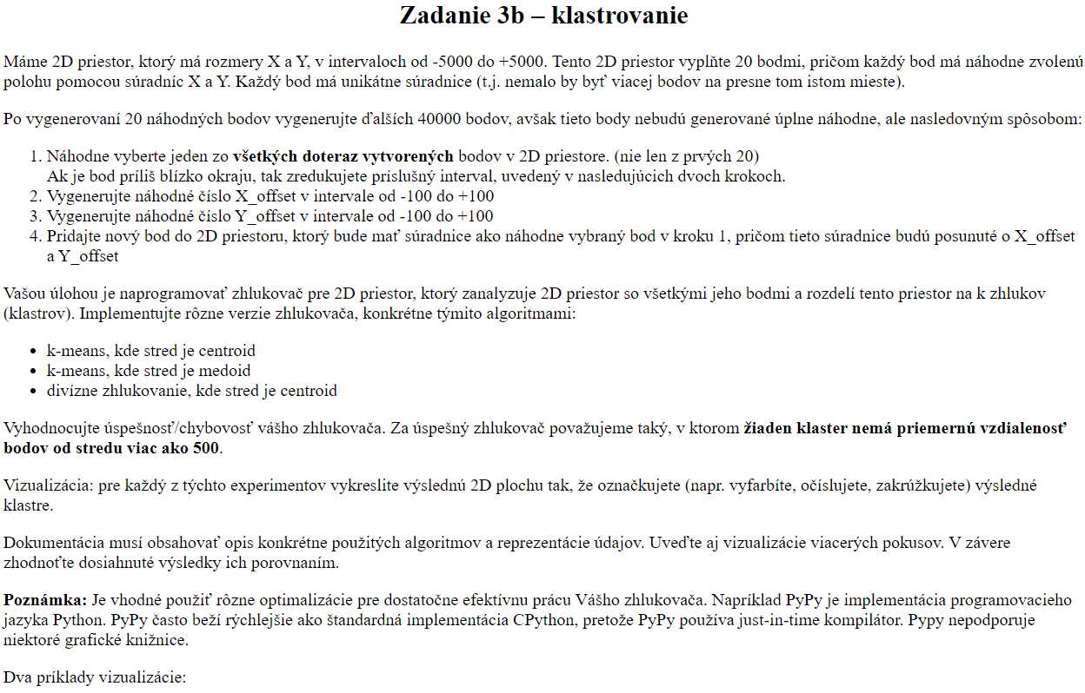

40k points



